From Degrees to Deployment: What Industry-Integrated Education Looks Like in Practice at Galgotias University
An engineering student should encounter electric-vehicle systems before joining an automotive company. A computer science student should build with AI, cloud platforms and modern development tools during the degree, not discover them during induction training. A management student studying analytics should work with the technologies that shape business decisions.
This principle is influencing programme design at Galgotias University. Collaborations with Accenture LearnVantage, IBM, Microsoft and byteXL, L&T EduTech, and Tata Technologies bring industry participation into curricula, laboratories, projects, faculty development and career preparation.
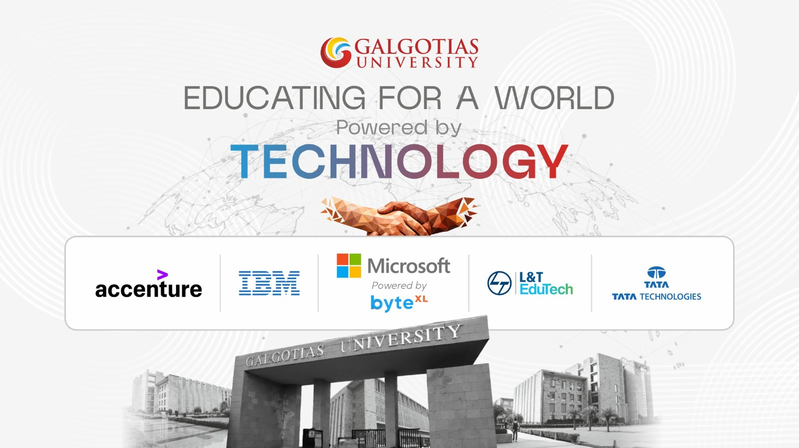
The result is a broad portfolio spanning artificial intelligence, cloud computing, quantum computing, business analytics, electric mobility, semiconductors, digital manufacturing and product development. Its value, however, will be determined inside classrooms and laboratories: by the problems students solve, the tools they master and the quality of work they can demonstrate.

Accenture LearnVantage: AI across engineering and management
The collaboration between Galgotias University and Accenture LearnVantage extends across technology and management education.
The four-year B.Tech programmes developed with Accenture LearnVantage offer pathways in Cloud and AI, Data Science and AI, Full-Stack AI and Design Engineering. Their curricula move through programming, mathematics and computational thinking into machine learning, cloud infrastructure, DevOps, deep learning, cybersecurity and scalable systems.
The partnership also includes BBA programmes integrated with AI, with specialisations in AI-integrated General Management and AI-powered Sales and Marketing. Students study established management disciplines alongside AI-enabled market intelligence, predictive analytics, digital finance, data visualisation, AI governance and product management.
Practical work is distributed across both streams. The learning model includes practitioner sessions, laboratories, case studies, industry challenges and live projects. Career preparation covers aptitude development, communication, résumé building and mock interviews.
The Accenture Centre of Advanced Studies gives this work a defined presence on campus. It also shows the scale of the academic intention. AI is being treated as an engineering capability, a management tool and a factor shaping how organisations operate.

IBM: four programmes, three emerging fields
The collaboration with IBM covers artificial intelligence, quantum computing and business analytics. Students can pursue a B.Tech specialisation in Quantum Computing, a BCA in Artificial Intelligence and Machine Learning, a BBA in Business Analytics or an MBA in Business Analytics.
Each programme responds to a particular need. Quantum computing introduces engineering students to a field whose commercial applications are still developing. The BCA programme builds technical competence in AI and machine learning. The business analytics degrees prepare management students to use data, predictive methods and business-intelligence tools in organisational decision-making.
IBM’s role also extends to curriculum development, faculty training, certifications, experiential-learning facilities, and access to technology and learning platforms. These provisions matter because specialised programmes require more than updated course titles. Faculty expertise, practical infrastructure and credible assessment must develop alongside the curriculum.

Microsoft and byteXL: sustained preparation in AI and machine learning
Galgotias University offers a four-year B.Tech in Computer Science and Engineering specialising in Artificial Intelligence and Machine Learning, in collaboration with Microsoft and powered by byteXL.
Its four-year structure gives students time to build the mathematical, computational and engineering foundations required for serious AI work. The association with Microsoft and byteXL adds an industry learning environment involving practical development, projects, certifications and career-focused preparation.
This sustained approach is important. Short courses can introduce an AI tool; they cannot replace the disciplined study required to understand algorithms, data, system design, deployment and responsible use. Placing the specialisation within a complete engineering degree allows those capabilities to develop in sequence.

L&T EduTech: engineering taught through industrial applications
The University’s work with L&T EduTech reaches across electric mobility, AI-enabled transportation, digital manufacturing, semiconductor technologies, Industrial IoT, cybersecurity, smart infrastructure, data science and full-stack development.
Its Advanced Electric Vehicle Centre of Excellence gives students access to EV systems, battery technologies, power electronics, charging infrastructure, simulation and diagnostics. These facilities allow engineering principles to be examined through working systems and realistic technical problems.
The four-year B.Tech in Electrical and Computer Engineering illustrates the academic scope of the partnership. Electrical engineering is combined with computing, embedded systems, artificial intelligence, EV technology, renewable energy, cybersecurity and data science. Laboratories, design work, industrial training and capstone projects run through the programme. Teaching contributions come from L&T experts as well as Galgotias University faculty. Examine the integrated B.Tech curriculum.
The collaboration currently includes four-year industry-integrated pathways for 336 students across several technology domains. L&T EduTech recognised Galgotias University with its Blue Chip Partner Award at NEXUS 2026.

Tata Technologies: 700 hours of product-development training
The Tata Technologies Learning Centre serves students in Mechanical, Electrical and Electronics Engineering. It was established following an MoU signed on 12 June 2025.
The programme requires 700 hours of training across two semesters. Tata Technologies subject-matter experts conduct physical sessions on campus, while assessments and learning modules are delivered through the company’s iGET IT platform.
Electrical and electronics students study high-voltage EV systems and work towards EV certification. Mechanical engineering students train on CREO and CATIA, two widely used MCAD platforms. The programme also provides capstone guidance and internship opportunities for selected participants. Galgotias University reports that 200 students are involved in the current academic cycle. Learn more about the Tata Technologies Learning Centre.

The test is what students can do
Corporate names attract attention. Educational substance lies elsewhere.
Does a student use professional tools repeatedly? Does the curriculum reflect current technical practice? Are projects demanding enough to expose weak understanding? Do faculty members receive the training required to teach emerging subjects well? Can graduates explain, build, test and improve their work?
The Galgotias University model places these questions inside the degree. Industry participation influences course design, laboratory experience, expert instruction, projects, certifications and professional preparation. Different partners contribute where their expertise is strongest.
Students still need strong fundamentals. They still need intellectual curiosity, discipline and the capacity to learn independently. Industry-integrated education cannot replace those qualities. It can give them a demanding context in which to develop.
That is the real promise of this portfolio: students encounter the technologies, expectations and working methods of their chosen fields while they still have the time, guidance and academic freedom to master them.

