PRESS NOTIFICATION
COMPREHENSIVE RESULT TABULATION PORTAL FOR CLASS XII
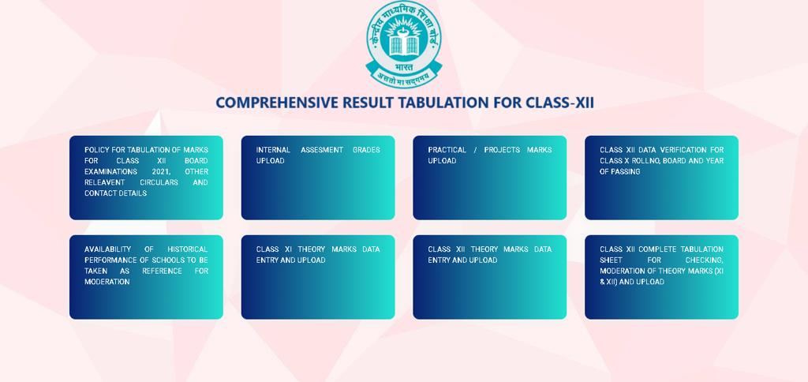
New Delhi 21st June, 2021
In order to facilitate schools in implementing policy for Tabulation of Marks/Grades for Class XII Board Examination 2021, a portal has been developed by the IT Department of CBSE in a very short period of time and implemented from today. This portal has the following sections: -
- INTERNAL GRADES UPLOAD
- PRACTICAL/ PROJECTS/INTERNAL ASSESSMENT MARKS UPLOAD
- CLASS XII DATA VERIFICATION FOR CLASS X ROLL NO, BOARD AND YEAR OF PASSING
- AVAILABILITY OF HISTORICAL PERFORMANCE OF SCHOOLS TO BE TAKEN AS REFERENCE FOR MODERATION
- CLASS XI THEORY MARKS DATA ENTRY AND UPLOAD
- CLASS XII THEORY MARKS DATA ENTRY AND UPLOAD
- CLASS XII COMPLETE TABULATION SHEET FOR CHECKING, MODERATION OF THEORY MARKS (XI & XII) AND UPLOAD
A sequence of the above mentioned activities has also been prepared and being activated from today on the portal while the rest will be activated in due course of time to make it easy for the schools. This latest IT initiative for providing logistic support to schools has been welcomed and appreciated by the schools at large.
“A system has also been developed for computation of Class X component of marks based on result data available with the Board in case of students who passed their Class X Board from CBSE only. For other Boards, CBSE with the help of Regional Offices will collect result data from respective State Boards for the purpose of computation of Class X component (30%) of marks of Class XII. The system will also compute Class XI component (30%) and Class XII component (40%)”according to Dr Antriksh Johri, Director IT, CBSE.
After collection of all marks, this portal will display complete tabulation sheet for the school with a feature of subject-wise marks and reference mean for the purpose of moderation of marks by the schools. This portal and the backend systems have eased out lots of burden of cumbersome calculations for the schools.

Team CBSE

