Press Release:
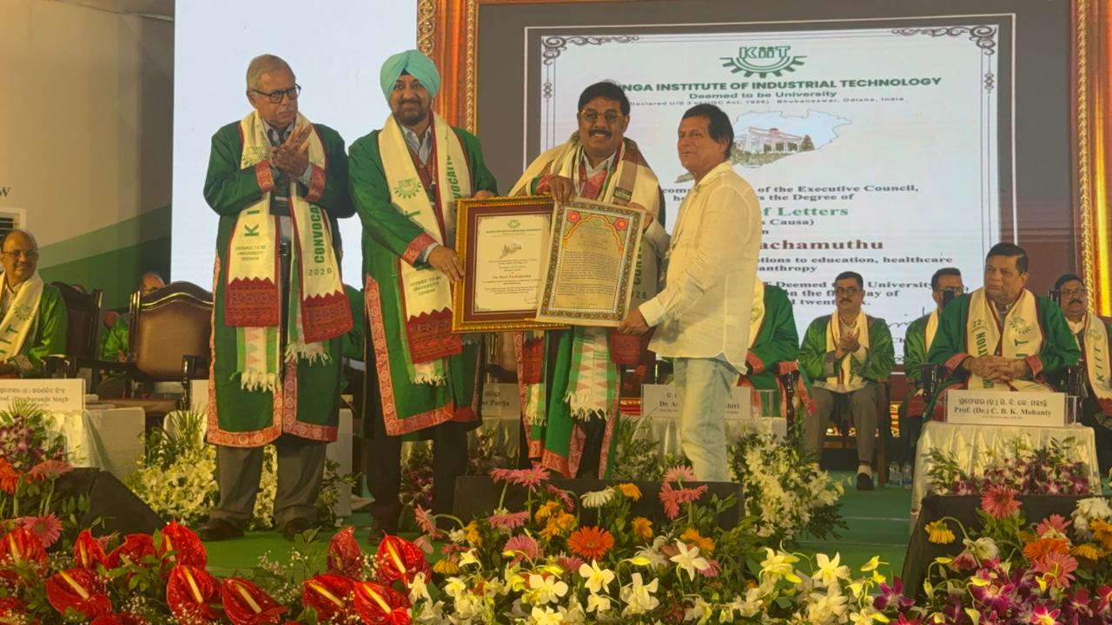
Dr. Ravi Pachamuthu, Pro-Chancellor (Administration), SRM Institute of Science and Technology, Conferred Doctor of Letters (Honoris Causa) by KIIT
The prestigious recognition honours his leadership and contributions across education, healthcare and institution-building.
Chennai: Dr. Ravi Pachamuthu, Pro-Chancellor (Administration), SRM Institute of Science and Technology has been conferred the prestigious Doctor of Letters (Honoris Causa) by the Kalinga Institute of Industrial Technology (KIIT), Bhubaneswar, Odisha.
The distinction recognises his vision, leadership and contributions across education, healthcare, philanthropy and institution-building. His work across these sectors reflects a commitment to expanding opportunities, strengthening institutions and contributing to the progress of individuals and communities.
The distinguished academic honour was conferred at a special ceremony organised by KIIT in Bhubaneswar, Odisha, on 5th October 2026. The ceremony brought together academia and industry to recognise distinguished contributions and institution-building.
Dr. Ravi Pachamuthu’s recognition marks a proud milestone for the SRM Group. As Pro-Chancellor (Administration) of SRM Institute of Science and Technology, he continues to contribute to the institution’s leadership and its broader commitment to education and service.
The honour celebrates a vision that extends beyond individual achievements, recognising the role of leadership in building institutions, broadening possibilities and creating lasting value for society.

