Press Release: For Immediate Release
Galgotias University Students Bring Pride to India with Outstanding Achievements at Global Diplomacy Conference in Malaysia
Sahil Rana wins Best Delegate Award, while Amaan Lone earns Most Outstanding Delegate Award at the Global Youth Diplomacy Model United Nations
Greater Noida, 17 July 2026: Continuing their impressive streak of bringing laurels to India on global platforms, students of Galgotias University have earned international recognition at the Global Youth Diplomacy Model United Nations (GYDMUN), held in Malaysia.
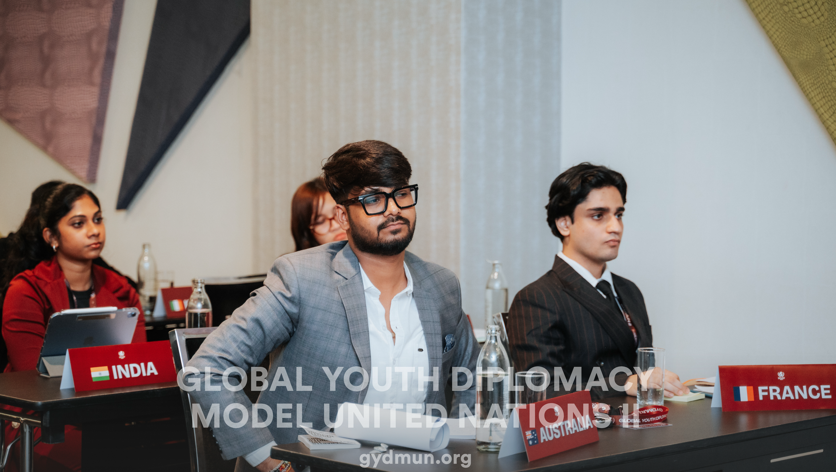
Galgotias University brings pride to India as Sahil Rana and Amaan Lone earn top honours at the GYDMUN in Malaysia
The prestigious international conference brought together delegates from more than 25 nationalities, creating a dynamic platform for young leaders to deliberate on pressing global issues. Participants engaged in discussions centred on diplomacy, international cooperation, the United Nations Charter and the Sustainable Development Goals.
Sahil Rana, a BA (Hons.) Political Science student from the School of Liberal Education, Class of 2027, won the Best Delegate Award. Amaan Lone, a B.Tech. Data Science student from the School of Computer Science, Class of 2028, received the Most Outstanding Delegate Award.
Competing alongside delegates from diverse cultural, national and academic backgrounds, Sahil and Amaan demonstrated exceptional research abilities, confident presentation, persuasive public speaking, diplomatic negotiation and critical thinking under pressure.
Throughout the conference, they articulated their assigned countries’ positions with clarity, responded thoughtfully to challenging questions and presented compelling, evidence-based arguments grounded in the principles of the United Nations. Their ability to engage constructively with participants from different cultures reflected the true spirit of Model United Nations and the importance of collaborative approaches to global challenges.
Sharing his experience, Sahil Rana said, “Winning the Best Delegate Award among participants from more than 25 nationalities is an incredibly proud moment for me. The experience taught me that success in diplomacy depends on thorough preparation and understanding perspectives different from one’s own. I am grateful to Galgotias University for encouraging me to learn beyond the classroom and giving me the confidence to represent India on an international platform.”
Reflecting on his achievement, Amaan Lone said, “Participating in GYDMUN was a transformative experience that challenged me to think critically, communicate with clarity and respond calmly under pressure. Receiving the Most Outstanding Delegate Award has strengthened my belief that students from every academic discipline can contribute meaningfully to conversations on global issues. I am thankful to the University and my mentors for their constant guidance and support.”
Dr Dhruv Galgotia, Chief Executive Officer of Galgotias University, said “Sahil and Amaan have made the University and the country proud through their exceptional performance on an international platform. Whether in diplomacy, technology or entrepreneurship, our students are proving that young Indians possess the knowledge, creativity and leadership needed to contribute meaningfully to the world. We remain committed to providing them with mentorship, resources and global opportunities that enable them to transform their potential into real-world impact.”
The honours earned in Malaysia add to a growing series of international achievements by Galgotias University students. At EDVentures 2026, hosted by The Education University of Hong Kong, student teams from the University represented India against 19 teams from 10 countries. Project TACTO secured the top spot for its inclusive, sensory-based coding education solution for visually impaired learners, while Tekurious Pvt. Ltd. was selected among the global finalists for its immersive virtual reality-based learning platform. Read about Galgotias University at EDVentures 2026.
The University also achieved remarkable success in Apple’s Swift Student Challenge 2026, with 18 students from its iOS Development Centre selected among only 350 winners worldwide. Their applications addressed challenges across accessibility, education, healthcare, artificial intelligence and augmented reality. Two students earned the distinction for the second consecutive year, demonstrating the consistency of the University’s innovation ecosystem. Read about the Apple Swift Student Challenge achievement.
Further strengthening its commitment to international academic exposure, Galgotias University selected and fully sponsored 16 students for a two-week Graduate Summer Programme at Girton College, University of Cambridge, under the memorandum of understanding between the two institutions. The immersive programme introduces students to frugal artificial intelligence, innovation and entrepreneurship, strategic thinking, global leadership communication, business modelling and executive storytelling. Culminating in a capstone venture pitch, the programme enables participants to learn from an internationally respected academic ecosystem, engage with multidisciplinary perspectives and develop solutions to contemporary global challenges. Read about the Cambridge Graduate Summer Programme.
Together, these accomplishments reflect Galgotias University’s expanding presence across international platforms in diplomacy, innovation, entrepreneurship, technology and academic excellence. They also underscore the University’s commitment to learning beyond the classroom and to nurturing socially responsible, globally aware and future-ready leaders.

About Galgotias University
Galgotias University is one of India’s leading multidisciplinary universities recognised for academic excellence, research, innovation, global collaborations, and industry aligned education. With a vibrant student community of over 50,000 learners and a global alumni network of more than 100,000 graduates, the University has built a rapidly growing ecosystem focused on technology, entrepreneurship, interdisciplinary learning, and real-world impact.
In the QS World University Rankings 2027 by Quacquarelli Symonds, Galgotias University was placed in the 1201-1400 global band and ranked 16th among private universities and 46th among all universities in India. In the Times Higher Education World University Rankings 2026, the University was placed in the 1201-1500 global band and ranked 27th among private universities and 65th among all universities in India. The University is also accredited with NAAC A+, one of India’s highest institutional quality ratings.
Galgotias University offers programmes across engineering, artificial intelligence, computer science, semiconductors, business, law, media, design, health sciences, hospitality, liberal education, and emerging interdisciplinary domains. In 2026, students secured more than 5,500 job offers from over 1,250 recruiters. The University has built strong industry and innovation partnerships with organisations including Apple, Infosys, IBM, Intel, Cisco, Tata Technologies, L&T EduTech, Capgemini, and Salesforce, while continuing to strengthen its global academic engagement and startup ecosystem.

